The size of space
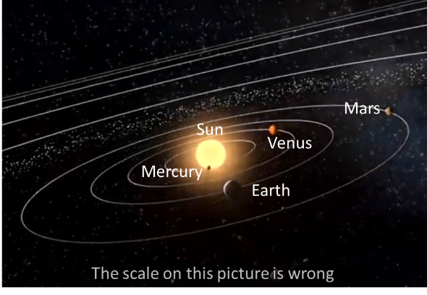
Space is very, very big and hard to imagine.
It is so big that an accurate picture of the Solar System does not fit into a book.
Pictures that we see of the Solar System are usually wrong.

1. How big is the Moon compared to the Earth?
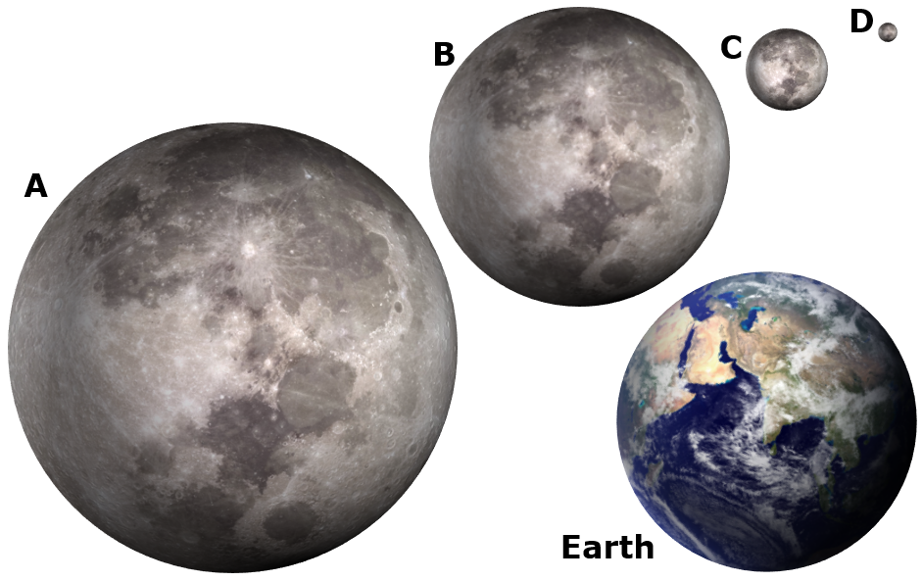

2. How far is the Moon from the Earth?
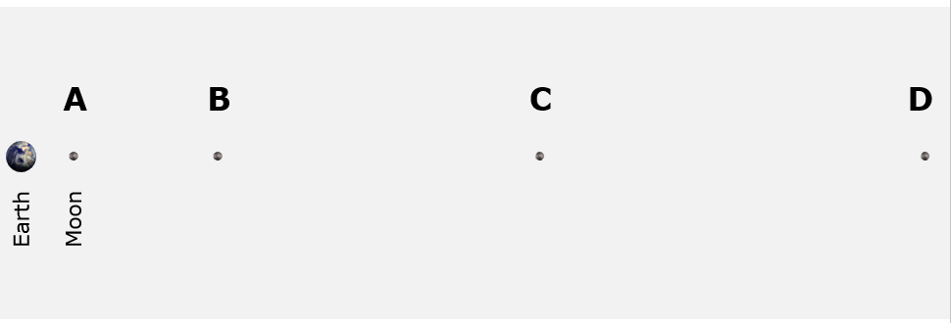

3. How big is the Earth compared to the Sun?
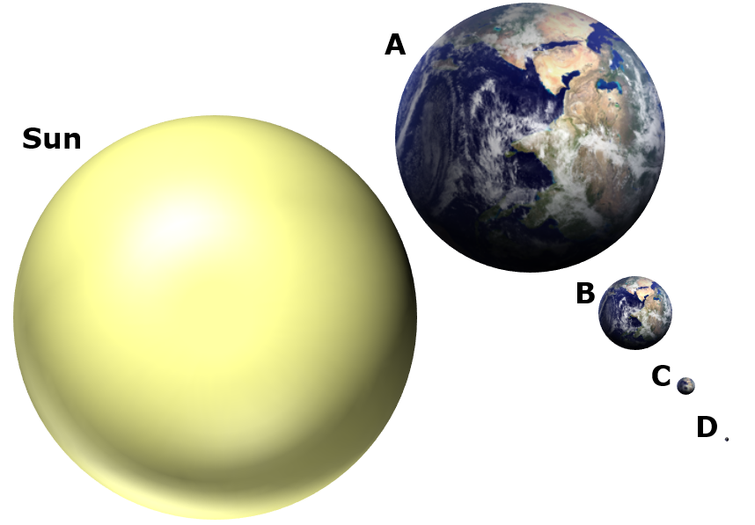

4. How far is the Earth from the Sun?
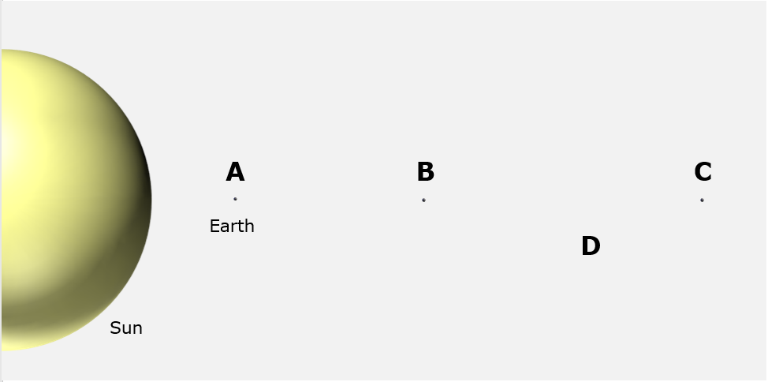
Six-and-a-half metres away
Physics > Big idea PES: Earth in space > Topic PES1: Solar System and beyond > Key concept PES1.1: Planets and the Solar System
Diagnostic question
The size of space

Overview
Learning focus: | In the Solar System: eight planets orbit a star called the Sun; moons orbit most of the planets; and the planets spin on their axes. We live on the Earth where: a year is defined as the time for the Earth to orbit the Sun; a day as the time it takes the Earth to spin on its axis; and the Moon orbits in about 28 days. The planets are very small compared to the huge distances between them.
Observable learning outcome: | - Describe the sizes of the Sun, Moon, Earth and other planets and the distances between them
Question type: | Diagnostic, simple multiple choice
Key words: | Earth, Sun, Moon

What does the research say?
It can be tempting to keep work on the Solar System simple and descriptive when in fact it is conceptually demanding (Osborne, 2011). In the sky the Sun appears to be smaller than the Earth but in fact is much bigger and very far away. The Moon looks to be the same size as the Sun, but is much, much smaller and also much closer.
One problem with models of the Solar System is the difficulty of scale. If the Earth is modelled as the size of a soccer ball, the Moon would be the size of a tennis ball orbiting at 6.6m from the Earth, and on the same scale the Sun would be the size of a (spherical) ten storey building about 2.6 kilometres away.
Diagrams of the Solar System in books and on posters are often poorly drawn and not to scale which can lead to persistent misunderstandings (Taylor, Barker and Jones, 2003). There is evidence that students typically have a poor understanding of the scale of space and it is recommend that there is a greater focus on the teaching of distance and size to help explain astronomical phenomena more clearly (Lelliott and Rollnick, 2009).
These questions help find out how students think about scale with the answers perhaps challenging false ideas.
Ways to use this question
Students should complete the question individually. This could be a pencil and paper exercise, or you could use an electronic ‘voting system’ or mini white boards and the PowerPoint presentation.
The answers to the question will show you whether students understood the concept sufficiently well to apply it correctly.
If there is a range of answers, you may choose to respond through structured class discussion. Ask one student to explain why they gave the answer they did; ask another student to explain why they agree with them; ask another to explain why they disagree, and so on. This sort of discussion gives students the opportunity to explore their thinking and for you to really understand their learning needs.
Differentiation
You may choose to read the questions to the class, so that everyone can focus on the science. In some situations it may be more appropriate for a teaching assistant to read for one or two students.
Expected answers
1. C (Moon’s diameter is approximately ¼ the diameter of the Earth)
2. D (Moon is about 30 diameters of the Earth from the Earth)
3. D (Sun’s diameter is approximately 100 times bigger than the Earth’s)
4. D (Earth is about 107 diameters of the Sun away from the Sun)
How to respond - what next?
The Moon and Sun, by coincidence, appear almost identical in size to each other because although it is much bigger, the Sun is also much farther away.
In pictures of the Solar System the sizes of the planets are often drawn to scale, in comparison to each other, but the Sun is then either drawn to a smaller scale or just a segment of it is shown (and then not necessarily to scale). This makes it hard to judge the size of the Sun to the planets.
In these drawings, it is often the case that the distances between planets are also drawn to scale. But, to fit them on a page this scale needs to be very much smaller than the scale used to draw their size.
If students have misunderstandings about the scale of size and separation of the Sun, Earth and Moon, it can help to make scale models. There are many ideas in books and online for doing this, for example students can use a suitable scale to mark distances of the planets from the Sun along a long strip of paper, or along a corridor.
Searching on the internet for ‘Solar System model scale calculator’ will find several websites that can be used to calculate scales in the Solar System. If you want to make a 3-D scale model, then expanded polystyrene balls of a wide range of sizes can be bought on the internet. The larger planets can be made from paper-mâché using a balloon as a mould. If this is done then ‘punch-balloons’ give a rounder shape than regular ones.
There is a very good video of a scale model of the Solar System on the Channel 4 (UK) programme: ‘Scientific Eye Space’ (about 12 minutes from the start). This uses the full length of the runway at Leeds-Bradford airport, in the north of England with students dropped off along the runway holding scale models of each planet. On this scale the Earth is the size of a blackcurrant and 76 m away from a beach-ball sized Sun. Please note if you use this video that it was made when Pluto was still considered a planet and Pluto is included in the model.
The following BEST ‘response activity’ could be used in follow-up to this diagnostic question:
- Response activity: The solar system

Acknowledgments
Developed by Peter Fairhurst (UYSEG).
Images: CC0 Public Domain, Peter Fairhurst (UYSEG).
References
Lelliott, A. and Rollnick, M. (2009). Big Ideas: A review of astronomy education research 1974-2008. International Journal of Science Education, 32:13, 1771-1799.
Osborne, J. (2011). Earth in Space. In Sang, D. (ed.) Teaching Secondary Physics. London: Hodder Education.
Taylor, I., Barker, M. and Jones, A. (2003). Promoting mental model building in astronomy education. International Journal of Science Education, 25:10, 1205-1225.

